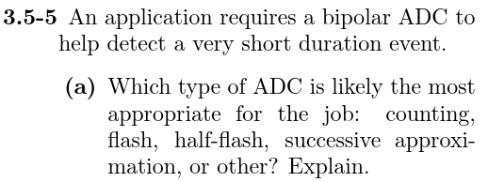

I would say a Flash type ADC would be appropriate. If this is a very short duration event, being able to sample at a very fast rate is important. We wouldn’t want to miss the event occurring between samples if we used a slower converter